

Website project

2025

December 29

Ntg school
Authored by: Youssef Yasser

About team:

We are team 3
Team leader: Abdulrahman
Coleader: Youssef Yasser
Team members is :
Rodina
Hager
Moaned
Ahmed Noor
Ahmed Hossam

About tools :

We use
Visual studio code
And orcal database
Api

NTG school

Tasks for this week:

Yousef Yasser : first section
Mohaned : second & therd section
Rodina: card section
Ahmed noor: reviews section
Hager fouad : offers section
Ahmed Hossam: footer

Design link : Figma Design

Screen shots for works:

First section: by Youssef Yasser

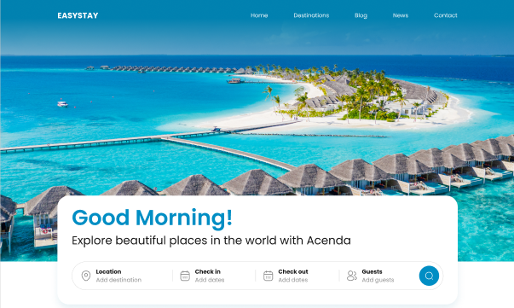

NTG school

Second section: mohaned

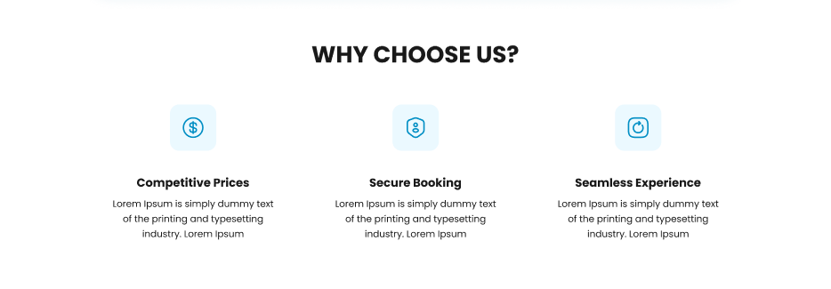



card section: by Rodina

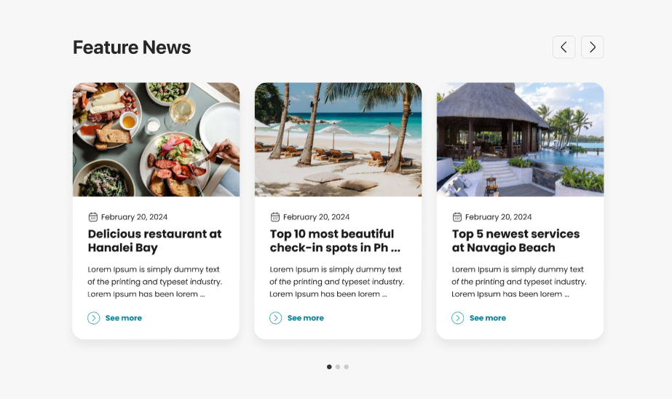

Reviews section: by ahmed nour
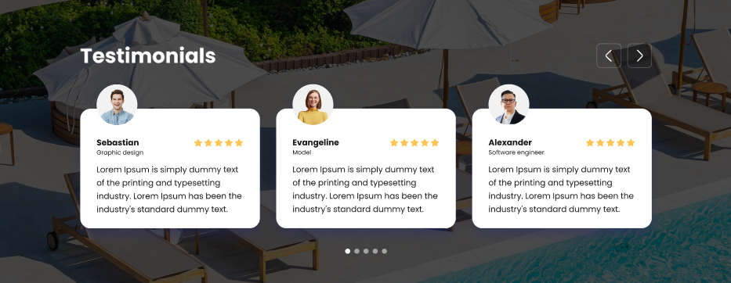

Offers section : by hager fouad
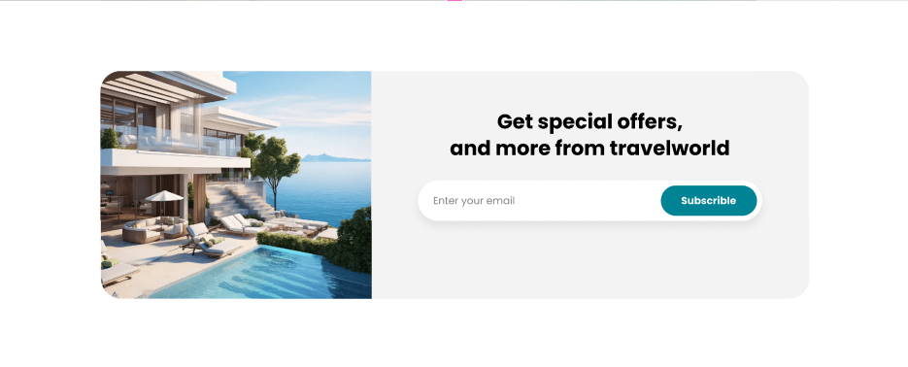

footer section: by ahmed Hossam

